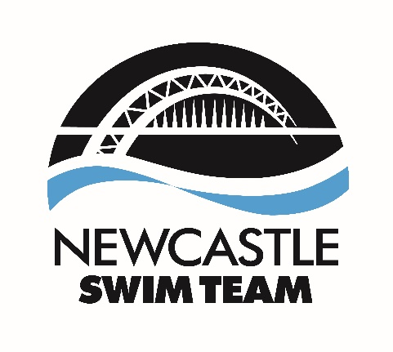

DOLPHIN GALA
SUNDAY 28th June 2026 1 – 3 pm
Gosforth Leisure Centre, Regent Farm Road, Gosforth
ENTRY INFORMATION
To enter the gala please follow the link to the Newcastle Swim Team Guest Entry Page where you will be able to enter and pay for your swims.
https://newcastleswimteam.myswimmingclub.uk/competitions/27
This link is also on the front page of the club website at www.newcastleswimteam.co.uk
Spectator entry is cash on the day.
5 Age Groups: 7/under, 8, 9, 10, 11-12
Events: 25m Freestyle, 25m Backstroke, 25m Butterfly, 25m Breaststroke
Swimmers can select as many events as they wish to swim
Swims are £3.50 each (payable on entry)
Entry to spectate on the day is £2.50 (cash preferred)
Event Order:
Event 1 – 25m Butterfly Girls Event 5 – 25m Breaststroke Girls
Event 2 – 25m Butterfly Boys Event 6 – 25m Breaststroke Boys
Event 3 – 25m Backstroke Girls Event 7 – 25m Frontcrawl Girls
Event 4 – 25m Backstroke Boys Event 8 – 25m Frontcrawl Boys

- The pool length is 25m of variable depth with 6 lanes & anti-wave lane ropes
- Manual timing will be in operation. Places up to 3rd will be announced with a medal ceremony in each age group and event. Results will be emailed to all participating clubs within 48 hours of the event and will also be placed on the Newcastle Swim Team website. .
- Events will be all strokes 25m (1 length). All events will be Heat Declared Winner.
- Five Age Groups for medals are 7/under, 8, 9, 10, 11-12, Age as at 28th June 2026.
- Medals will be issued to the first three places in each age group and events as listed above. A competitors medal will be awarded to all swimmers.
- Entry Fees £3.50 per swim. Payment should be made via the link above.
- Closing date for entries is Midnight Friday 12th June 2026. An entries for checking will be posted on the Newcastle Swim Team Website by Wednesday 17th June 2026, please check this carefully for errors and omissions and email admin@newcastleswimteam.co.uk with any corrections.
- For safety reasons only swimmers who can perform an SE competitive start may perform a shallow racing dive from the starting blocks. Other swimmers may start in the water. Swimmers are asked to remain in the water until asked to leave the pool at the end of each race.
- Access to pool-side will be restricted to swimmers, coaches, officials and authorised helpers in line with Swim England Child Protection Policy.
- The use of any photographic equipment (still, video or digital including mobile phones with photo facilities) by members of the public is strictly prohibited by GLL and Newcastle Swim Team.
- Admission for spectators will be £2.50, cash payable on the door for admission. Adult admission may be limited to 1 spectator per swimmer due to capacity constraints at Gosforth Pool dependant upon number of entries.
- Any queries should be directed to the Meet Manager Julie Row – admin@newcastleswimteam.co.uk

